**Electronic Supplementary Material 3**

***Garnet skarn T-XCO2 modelling at 2 kbar (whole rock data from Electronic Supplementary Material 2)***

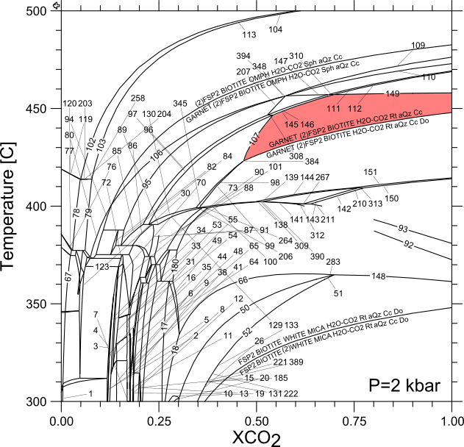

***Amphibole skarn T-XCO2 modelling at 2 kbar*** ***(whole rock data from Electronic Supplementary Material 2)***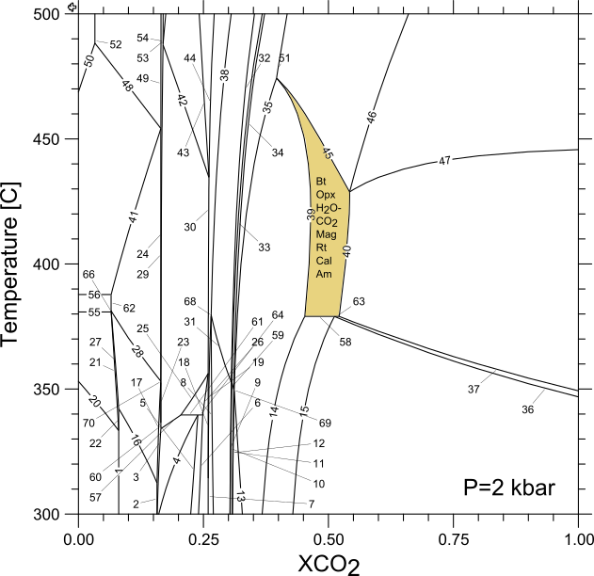

***Pyroxene skarn T-XCO2 modelling at 2 kbar*** ***(whole rock data from Electronic Supplementary Material 2)***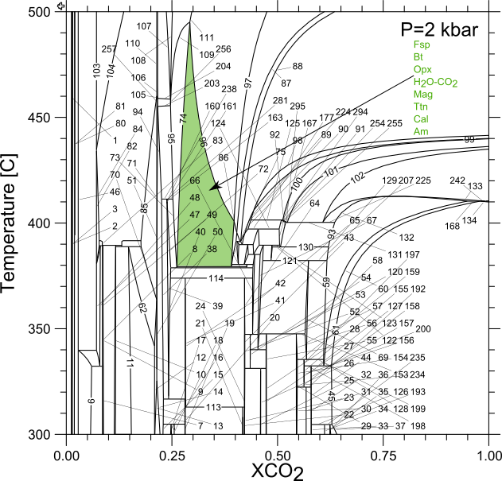

***Magnetite skarn T-XCO2 modelling at 2 kbar*** ***(whole rock data from Electronic Supplementary Material 2)***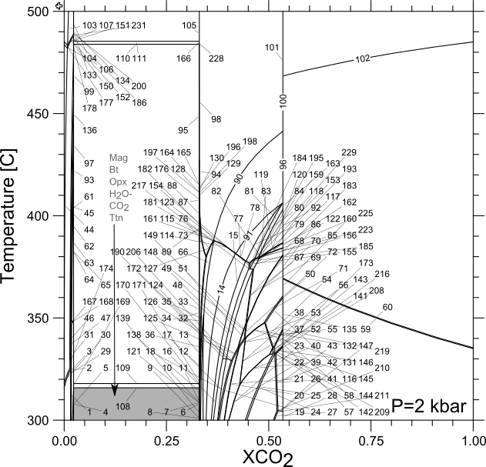

***Garnet skarn T-XCO2 modelling at 5 kbar*** ***(whole rock data from Electronic Supplementary Material 2)***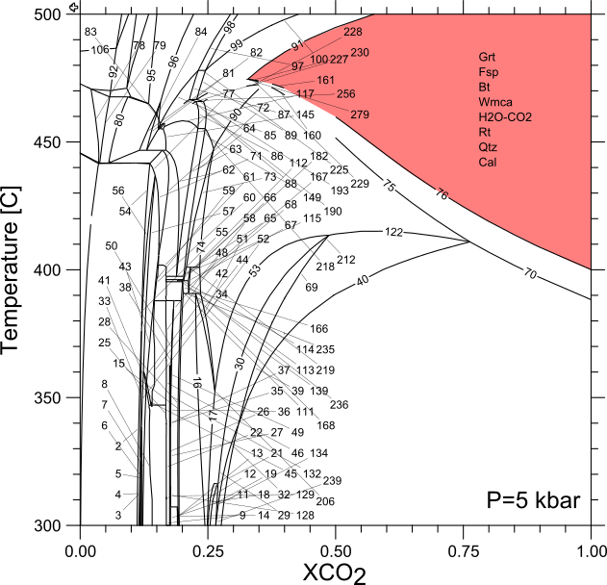

***Amphibole skarn T-XCO2 modelling at 5 kbar*** ***(whole rock data from Electronic Supplementary Material 2)***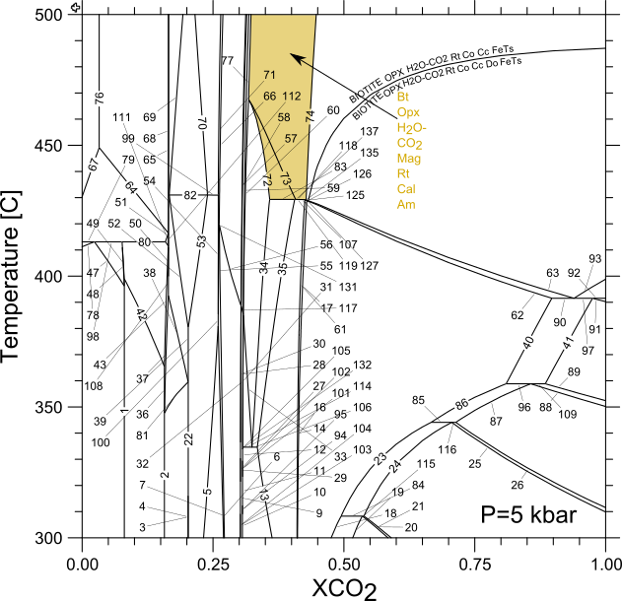

***Pyroxene skarn T-XCO2 modelling at 5 kbar*** ***(whole rock data from Electronic Supplementary Material 2)***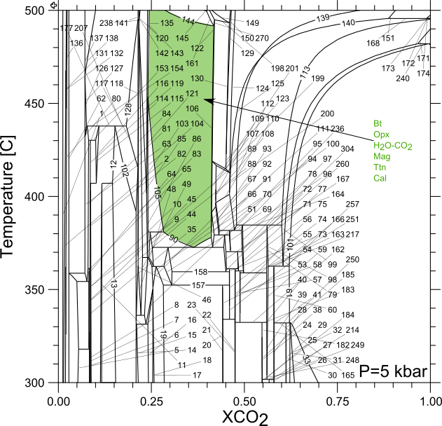

***Magnetite skarn T-XCO2 modelling at 5 kbar*** ***(whole rock data from Electronic Supplementary Material 2)***